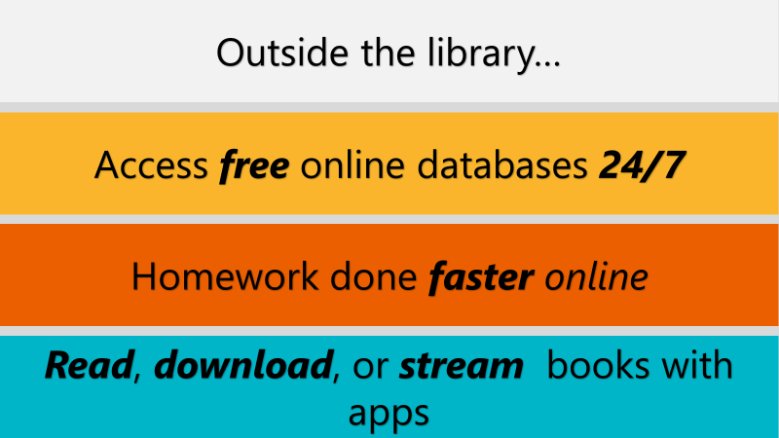 STEP 1:LIBRARY PASS LINK (PRESS LIBRARY PASS LINK)

STEP 2: (SELECT MIDDLE)

STEP 3: (SCROLL AND SELECT)

STEP 4:

STEP 5:
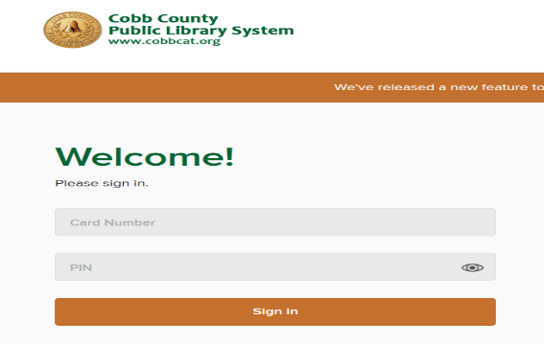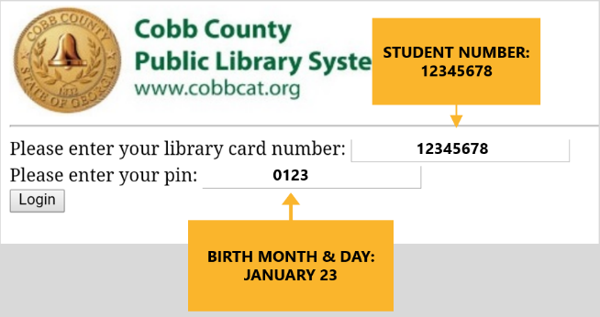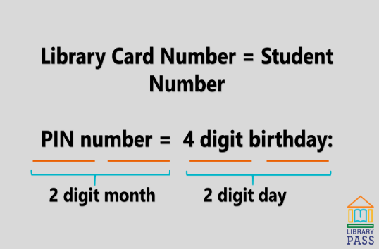

STEP 6: Access eBooks, Audio Books, Databases. Check books in and out from your device. Place resources on hold. All resources automatically check back in should you forget to return on line.
